1° Open Rapid Chess Tournament
“Gjovalin Kadeli”

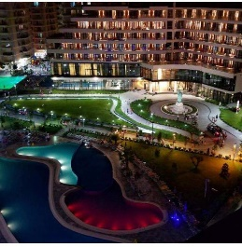
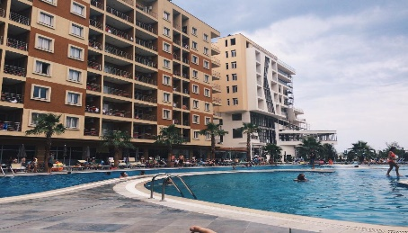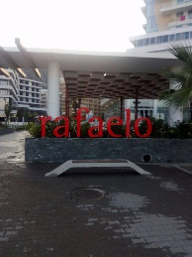

- Invitation
This is the official invitation to all the FIDE Members Chess Federations and eligible players, to participate in the 1° Open Rapid Chess Tournament “Gjovalin Kadeli”
The championship will be held in Rafaelo Resort” Shengjin, Lezhe15th March 2020, under the auspices of the “Lezha Chess Club”
- Playing venue: The games will take place in the conference hall of “Rafaelo Resort” Shengjin, Lezhe - Albania

- Tournament Schedule

Round | Time
Registration Confirmation | 09:00 - 10:00
Open ceremony | 10:00
Round 1 | 10:30
Round 2 | 11:20
Round 3 | 12:10
Round 4 | 13:00
Round 5 | 13:50
Lunch Break
Round 6 | 15:00
Round 7 | 15:50
Round 8 | 16:40
Round 9 | 17:30
Closing Ceremony | 19:00
- Technical Regulations
  - Organizers: Chess Club “Klubi Shahut Lezhe” (KSHL)
  - Race System: Swiss System nine (9) rounds
  - Time Control: 15 minutes for game with 5 seconds increment from move 1

  - Tournament is played according to the rules of Rapid play Laws of Chess (FIDE Handbook, E.I.01A Appendices, art. 4)
- Tie-breaks System definitions:
- Buchholz - 1 (worst)
- Buchholz
- Sonneborn-Berger
- Prizes, Titles & Certificates
  - The Organizer shall award trophies to the players taking the first three places in each event. The Organizer shall also award Gold, Silver and Bronze medals to the players taking the first three places in each category. Trophies for 1st place and medals are awarded after applying tie-breaks.
  - Total prizes fund: 1800 Euro

Prizes | Euro
1st place | 400
2nd place | 320
3rd place | 250
4th place | 180
5th place | 150
6th place | 110
7th place | 90
8th place | 70
9th place | 60
10th place | 50
SPECIAL CATEGORIES
Best U18 | 30
Best S55 | 30
Best Rtg U1900 | 30
Best Rtg U2100 | 30

  - The prizes cannot be shared and are attributed to the winner, according to final ranking.
  - In case, one player deserves more than one prize, he/she will only be rewarded with the higher valued one (in accordance to: money price)

- Arbiters:
Chief Arbiter: IA Burhanudin Misini
Deputy Arbiter: FA Eraldo Gjoni
Arbiters: IA Marin Çollaku,
IA Sasko Lakinski,
FA Ermal Çuli

- Accommodation:

  - “Rafaelo Resort” Single room + breakfast 20 €/night; Double room + breakfast 30 €/night
  - Room reservations are made at the email :

  - For other accommodation options or more informations contact at the email kshlezha@gmail.com

- Registration: no later than 14th March 2020
by e-mail at kshlezha@gmail.com
text message to 00355 69 370 6211 ,

- The maximum entry limit is set at 300 chess players. A chess player is registered in the moment he/she send the application and find his/her name in tournament chess-result link http://chess-results.com/tnr511114.aspx?lan=1

- Entry Fee: 5 Euro/person; GM, IM, FM, WGM, WIM, WFM titled, free Entry Fee

- Tournament Director & FIDE International Organiser: Mrs Majlinda Pilinci
- Contacts: Tournament Manager: Eraldo Gjoni

