European School Championship and Conference in Romania

Report of Ion Dobronauteanu

by Uvencio Blanco Hernández

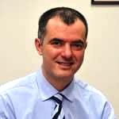

Ion-Serban Dobronauteanu

Presentation
Ion-Serban Dobronauteanu (1968) is of Romanian origin and speaks Romanian, English and French. He is a member of our Chess and Education Commission FIDE, president of the Balkan Chess Federation (BALC) and treasurer of the European Chess Union (ECU).
He is also National Chess Master, organizer of several editions of Bucharest Open Tournaments, of the matches between Anatoli Karpov against Andrei Istratescu (2005) and Veselin Topalov against Dieter Nisipeanu (2006). He is a member of the Organizing Committee of the Tournament of the Kings - Bazna, Romania, the Balkan Grand Prix chess circuit and the European School Chess Championship 2019.
Dobronauteanu is a graduate of the Polytechnic University and the Academy of Economic Studies of Bucharest and is studying for a doctorate in agricultural economics. Shareholder and Deputy General Manager of Euro Trade Invest SA (food and non-food trade) and shareholder and Export Coordinator of Murfatlar Romania SA (wine production).
He is also president and vice-president of the National Interprofessional Wine Organization and of the National Association of Wine Producers and Winegrowers.
On this occasion he presents us with a Report on the results of this championship and his impressions of the conference entitled "Education through Chess".

Report
Colleagues, greetings from Romania!.
Please receive here an information about the recent European School Championship and "Education through Chess" conference held in Mamaia Resort, Romania.

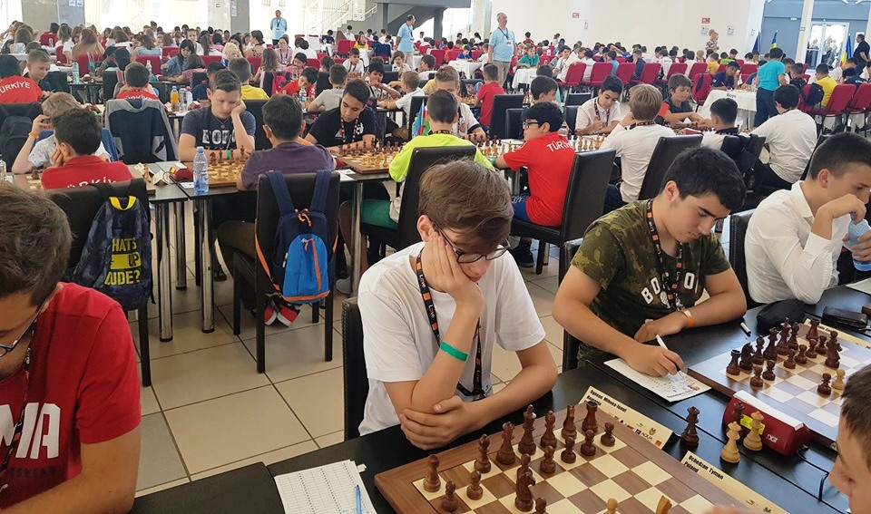

Play hall of the European School Championship

The championship gathered 309 players from 20 countries and the participants enjoyed a nice event and fine summer weather on the Black Sea shore. We were glad to welcome ECU leadership - president Zurab Azmaiparashvili and board members together with other chess friends.
On this occasion we scheduled a Chess in school conference with the initial goal to honor the 20 years activity of ISCU, the association run by our dear friend Alexander Kostyev. This special moment was marked by awarding by Zurab to Alexander a nice trophy on behalf of ECU.
One important achievement was that we succeeded to organize the conference under the patronage of the Council of the European Union, which gives a valuable recognition of all our work! In fact, Romania is holding for this first half of year the Presidency of the Council of the EU and after many months of efforts, the Romanian organizers obtained for the conference the Patronage of the Romanian Presidency of the EU Council. This new recognition at European Union level can be used in the future by everybody to show as an argument the support from EU institutions for the education through chess, our main focus.
The main goal of the conference was to show progress in various EU countries following the Written Declaration 50/2011 of the EU Parliament about the introduction of chess in education systems of member states, and to share good practices of European chess federations in implementing chess in schools.
The conference was organized in a nice room inside the playing venue and there were 4 speakers on site: Zurab Azmaiparashvili (ECU), Almog Burstein (ISR), Ozgur Solakoglu (TUR) and Vlad Ungureanu (ROU), 2 live interventions + materials by Skype: Alessandro Dominici (ITA) and Jesper Hall (SWE), 2 recorded videos: Judit Polgar (HUN), Tomasz Delega (POL) and one message of Alexander
Kostyev (as he had to leave in the meantime for an important meeting in
Russian Chess Federation). It was not easy task to organize the conference among all the other activities, but we consider it was a successful one.

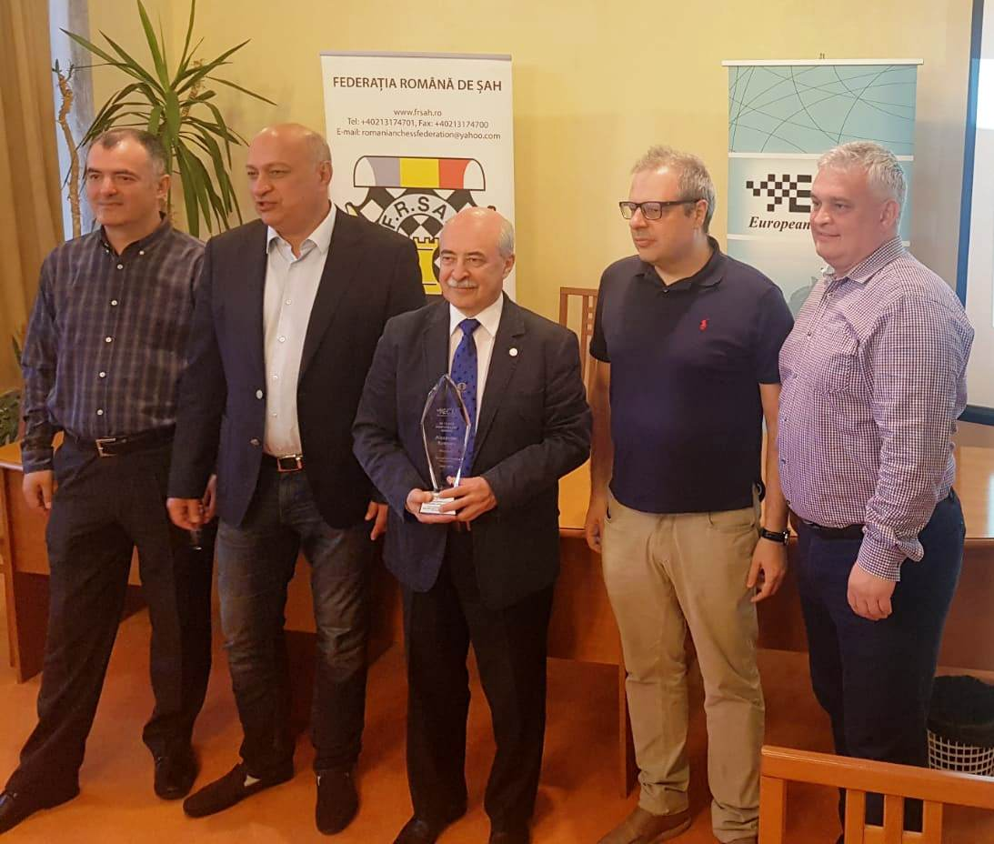

Homenaje a Alexander Kostiev por los 20 años de la ISCU

Here you can find the materials presented, all are very interesting and
useful, proving the great work and achievements on continental level:
http://frsah.ro/index.php/2019/06/08/education-through-chess-conference/

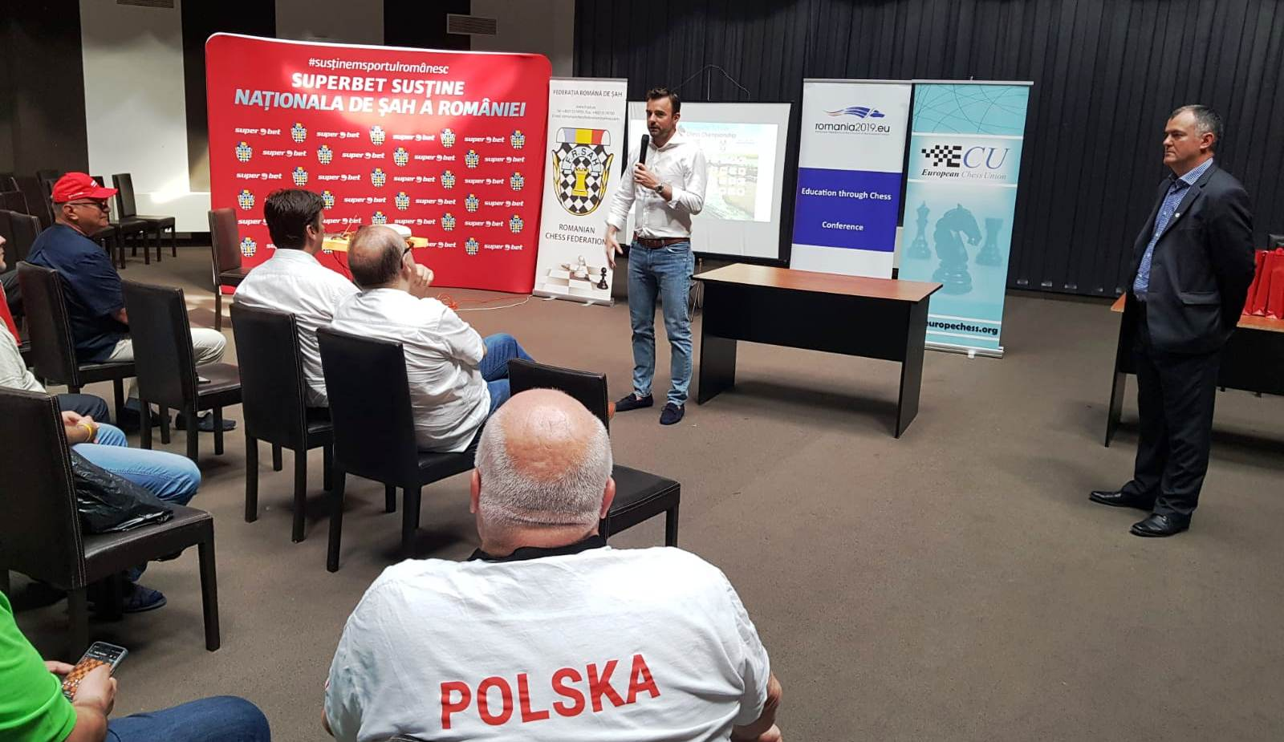

Un aspecto de la conferencia “La Educación a través del ajedrez”
We are very grateful for the effort of the lecturers who spent their valuable time to submit this materials to the conference and we do believe that the patronage of the EU Council on this occasion will be useful for future CIS activities. Attached yo

can find some relevant photos from the events.

Ion Dobronauteanu.-

